2024 11 21 QUI

Angular Material

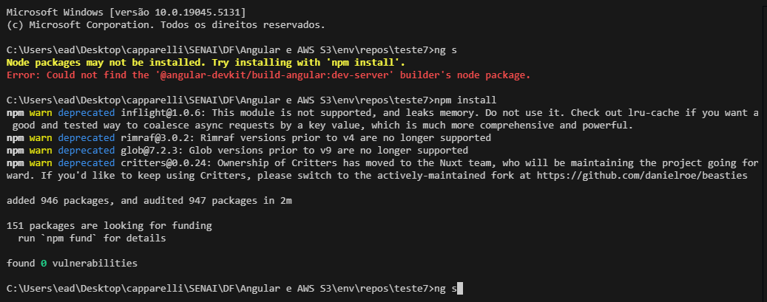

Mandar para Laryssa, pelo WhatsApp....

ng new angular-material

cd angular-material

ng add @angular/material@

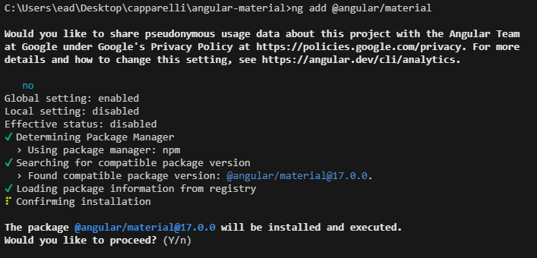

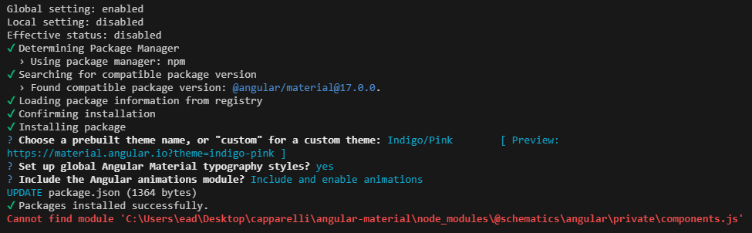

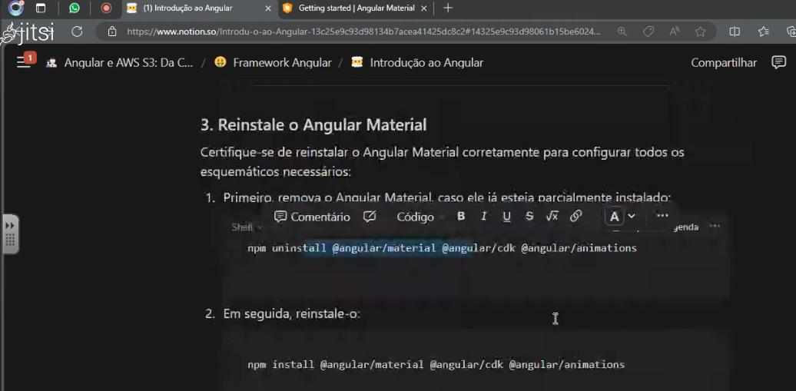

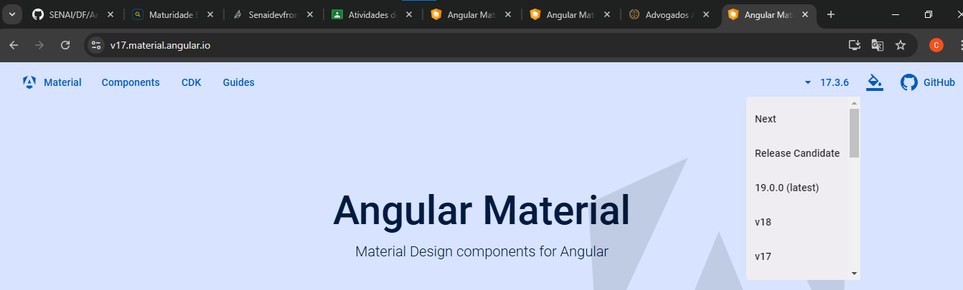

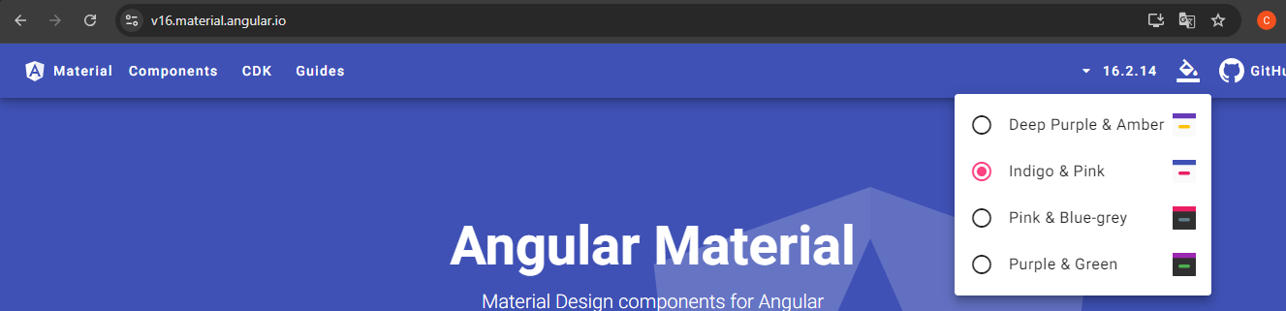

<https://sticky-ball-fe1.notion.site/Introdu-o-ao-Angular-13c25e9c93d98134b7acea41425dc8c2>

npm install @ngmodule/material-carousel **--force**

Djalma

Djalma disse:

import { Component } from '@angular/core';

import { NgModule } from '@angular/core';

import { MatButtonModule } from '@angular/material/button';

import { MatIconModule } from '@angular/material/icon';

import { MatToolbarModule } from '@angular/material/toolbar';

import { MatSidenavModule } from '@angular/material/sidenav';

import { MatListModule } from '@angular/material/list';

import { MatTableModule } from '@angular/material/table';

@NgModule ({

declarations: [],

imports: [

MatButtonModule,

MatIconModule,

MatToolbarModule,

MatSidenavModule,

MatListModule,

MatTableModule,

],

providers: [],

bootstrap: []

})

export class AppModule { }

@Component({

selector: 'app-root',

standalone: true,

imports: [],

templateUrl: './app.component.html',

styleUrls: ['./app.component.css']

})

export class AppComponent {

displayedColumns: string[] = ['nome', 'status'];

processos = [

{ nome: 'Processo 1', status: 'Em andamento' },

{ nome: 'Processo 2', status: 'Concluído' },

{ nome: 'Processo 3', status: 'Pendente' },

];

}